ID: Embodied Interactions

# Initial Research

From the offset my group and I had decided on Clifton Suspension Bridge, especially after our visit there. However, the visit came with a lot of enlightenment on various factors as well as reflection on our original angle. Initially, we wanted to create an interaction that was based on the suicide history of the bridge, however once we talked to the on-site manager of the Visitor Centre, it became very apparent we would not be able to access data, nor were the guides keen on the idea. As a result of this, we looked into other factors of the bridge which were discovered through the use of our research questions before investigating the area onsite as shown in Figure 1.

Figure 1 - Questions for Investigating Area

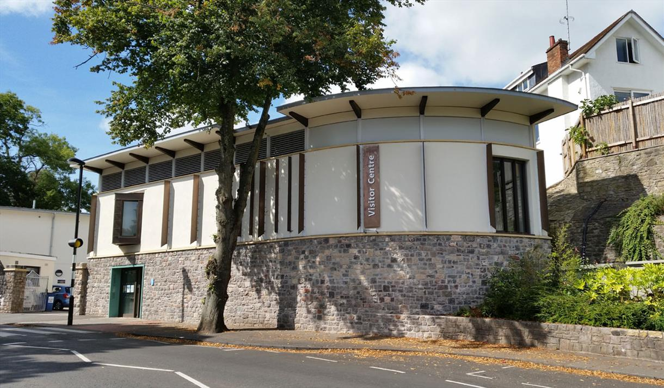During this process we noticed the Visitor Centre is heavily overlooked with little to no traction, this was including us. With this in mind, we focused our attention away from the bridge and more on the Visitor Centre and how a suitable interaction could possibly increase visitors.

Figure 2 - Clifton Suspension Bridge & Visitor Centre

# Design Brief

After observing the area, we noticed two important factors:

1. There were a lot of school trips into the area or pedestrians with kids
2. The bridge/visitor centre was missing a source of entertainment.

Figure 3 - Design Brief Challenge Summary

We had engaged in talks with the onsite manager of the centre and were informed that the place was of education but there was indeed room for entertainment in the centre. The centre has two floors with a few interactions.

The first floor has an interaction where you stand a scale, and it measures the bridges capacity of how many of the participant it can hold. As well as an architectural interaction that plays sounds when buttons are clicked.

Figure 4 - Clifton Suspension Bridge Visitor Centre Interior

The second floor has a playroom for kids where they can construct bridges with blocks.

While interactions exist in the visitor centre they are not of great interest and lack a strong pull factor. Therefore, our design brief shaped into creating a design that would have people coming back to show others and engage with, specifically of a young demographic.

Figure 5 - ­Interactions within Visitor Centre

# Design Research

Before developing an initial interaction, I conducted research into existing interactive designs. The goal was to help ideate possible design solutions for the Visitor Centre, this included research into sound design, motion detection as well as inherently interesting design, not necessarily interactive.

One of the first interactions was “Colston’s Last Journey… an interactive audio project. A sea of interactive audio is layered over the centre of Bristol/UK”. This helped construct the idea of possible noises within the bridge, perhaps as construction was going on, however as mentioned earlier, this idea has already been established on the site.

Figure 6 - Clock Screen in Schiphol Airport, Netherlands

Another inspiration was the clock interface in Schiphol Airport. This interesting and unique design showed that there was no limit to how outlandish a design idea could be, as long as it was accessible and provided a user with clear feedback and purpose, any design was acceptable.

Finally, there was research into motion detection, due to “increasingly being used in the design of interactives spaces, computer-mediated environments, and virtual user experiences”, our target audience of teens should potentially find such interaction second nature and understand the goal at a quick glance.

# Early Design

# Final Design Solution & Prototype

# Conclusion

# References

Atlas Obscura (2018) *Schiphol Clock.* Available from: <https://www.atlasobscura.com/places/schiphol-clock> [Accessed 07 December 2023].

Colstons Last Journey (2023) *Colstons Last Journey.* Available from: <https://www.uwe.ac.uk/study/study-support/study-skills/referencing/uwe-bristol-harvard#webpages> [Accessed 07 December 2023].

Great West Way (2023) *Clifton Suspension Bridge Visitor Centre.* Available from: <https://www.greatwestway.co.uk/see-and-do/clifton-suspension-bridge-visitor-centre-bristol-p1389081> [Accessed 07 December 2023].

Rydon (2023) *Clifton Suspension Bridge Visitor Centre.* Available from: <https://www.rydon.co.uk/clifton-suspension-bridge-visitor-centre> [Accessed 07 December 2023].

Escamilla, A. Melenchón, J. Monzo, C. and Morán, J, A. (2012) Interaction designers’ perceptions of using motion-based full body features. *International Journal of Human Computer Studies* [online]. Volume 155. [Accessed 07 December 2023].

# Bibliography

Brunel 200 *The Clifton Suspension Bridge.* Available from: <http://www.brunel200.com/suspension_bridge.htm> [Accessed 30 November 2023].

Ciolfi, L. (2004) *Situating 'Place' in Interaction Design: Enhancing the User Experience in Interactive Environments*. PhD, University of Limerick. [Accessed 30 November 2023].

Clifton Suspension Bridge Trust (2023) *Visitor Centre*. Available from: <https://cliftonbridge.org.uk/visit-explore/visitor-centre/> [Accessed 16 October 2023].

Djajadiningrat, T., Overbeeke, K. and Wensveen, S. (2002) But how, Donald, tell us how? *Proc. of DIS'02* [online]. pp. 285-291. [Accessed 30 November 2023].

Hornecker, E. Buur, J. (2006) Getting a Grip on Tangible Interaction: A Framework on Physical Space and Social Interaction. *CHI 2006 Proceedings* • *Designing for Tangible Interactions* [online]. [Accessed 30 November 2023].

Stanton, D. et al. (2001) Classroom Collaboration in the Design of Tangible Interfaces for Storytelling. *Proc. of CHI'01* [online]. pp. 482-489. [Accessed 30 November 2023].

Visit Bristol (2023) Clifton Suspension Bridge. Available from: <https://visitbristol.co.uk/things-to-do/clifton-suspension-bridge-p24661> [Accessed 16 October 2023].

Wikipedia (2023) *Clifton Suspension Bridge*. Available from: <https://en.wikipedia.org/wiki/Clifton_Suspension_Bridge> [Accessed 16 October 2023].